NEW ENGLAND INSTITUTE OF TECHNOLOGY

Information Technology Department

Quest #2

Data Structures and Algorithms (SE 394)
Due: Week #2



[Type your name here]

Developer

[Type current date here]

Date

George Saban

Instructor
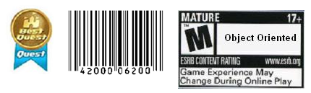

Requirements:

Instructions:
- According to some research, industry values documentation, and excellent written and oral communication skills. The purpose of this part of the class is to encourage you to gain these skills.
- Backup your work to your USB drive for this material may come out as part of your examination.
- Make a copy of this entire document and add your work into it.
- Submit to Blackboard at the same link where you got this document.
- Points will be a deducted if submitted on the wrong place, or if these instructions are not followed.
[You can earn a maximum of 40 points for this lab. Refer to the syllabus for late point deductions.]

Problem Statement

Part I: | – this will help you understand Big-O and Asymptotic Complexity

- Define Computational Complexity.
  - The measure of effort required for a function to execute.
- Define Asymptotic Complexity.
  - An approximation of a functions efficiency.
- What is big-O notation? Include how functions f(n) and g(n) are expressed in this notation.
  - Big-O notation is the approximation of the upper limit of a function.
f(n) <= O(g(n))
- What is big-Ω (omega) notation? Include how functions f(n) and g(n) are expressed in this notation.
  - Big- Ω notation is the approximation of the lower bounds of a function.
f(n) >= O(g(n))
- What is big-Θ (theta) notation? Include how functions f(n) and g(n) are expressed in this notation.
  - Big- Θ notation is the combination of big- O and big- Ω notation to determine a range.

Part II: | – This will help you master your understanding of asymptotic complexity.

Find the complexity of the function used to find the location of the boss character Find the complexity of the function used to find the location of the boss character on an 8x8 grid. You may randomly generate the row and column location of the boss prior to searching its location. Show your:
(1) Java code that searches for the boss anywhere on the grid. The function should display the row and column coordinates of the boss.
(2) Equation for the code analysis of the C++ function that you have written in step (1). __1 + n + 3n________________________________
(3) What classification of asymptotic complexity did your algorithm fall under? ___ Quadratic O(n^2)_______________________________ 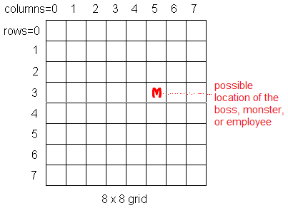

Analysis and Design:

Hints
- For Part I: All definition can be found in chapter two of your reference book. Also, you may consider the Internet for similar explanations.
- For Part II: Study textbook’s section 2.7 (Finding Asymptotic Complexity) examples on pages 64 to 66.
- Java documentation link: http://java.sun.com/j2se/1.4.2/docs/api/
- First chapter of the reference book is a review of the Java language. Also, thinking in Java book link: http://www.odioworks.com/46-Bruce_Eckel's_Free_Electronic_Books.html

Code Development:
package FindMonster;

public class FindMonster {

public static int[] FindMonster(int[][] grid){

int[] coordinates = new int[2];

for(int rows = 0; rows < grid.length; rows++){
for(int col = 0; col < grid[rows].length; col++){
if(grid[rows][col] == 1){
System.out.println("You found the monster!!");
coordinates[0] = rows;
coordinates[1] = col;
}
}
}
return coordinates;

}

public static int[][] InsertMonster(int[][] grid){

for(int rows = 0; rows < grid.length; rows++){
for(int col = 0; col < grid[rows].length; col++){
grid[rows][col] = 0;
}
}

grid[(int) Math.abs(Math.round((Math.random()*10 - 2)%grid.length))]
[(int) Math.abs(Math.round((Math.random()*10 - 2)%grid[0].length))] = 1;

return grid;
}

public static void main(String[] args) {
// TODO Auto-generated method stub

int[][] monsterGrid = new int[8][8];
InsertMonster(monsterGrid);
int[] monsterCoords = FindMonster(monsterGrid);
System.out.println("Monster is located at coordinates: (" + monsterCoords[0] + ", " + monsterCoords[1] + ")!");
}

Testing:
What is testing for? Every program you wrote, you are responsible for unit testing it. The first thing to do, once you have a program that “basically works”, is to try to break it. Try to feed your program input(s) in the hope of getting it to misbehave. By “hope” means that the challenge here is to find as many errors as possible, so that you can fix the errors before anybody else finds them. If you go into this exercise with the attitude that “my program works, and I don’t make errors!”, then you won’t find many bugs, and you will feel bad when you do find one or when someone finds one. You’d be playing head games with yourself! The right attitude when testing is, “I’ll break it! I’m smarter than any program--even my own!”
Feed (or try) a few such “problematic” inputs to your program and try to figure out in how many ways you can get it to misbehave. Can you get the program to crash? Testing is a very important part of game development, and can actually be fun. You may input data that is not “sensible”. A program ideally catches all errors, not just the sensible ones--this will make your program resilient against “strange input.”
As a goal, you would like the test to exercise every statement in your program, at least once. Test both positive and negative scenario. One example of positive testing is--if you have an input that requires an integer value, would it work if you give it the numeral 7? Moreover, as an example of negative testing: what happens if you give the previous program a string input of “seven” (instead of the numerical 7)? Identify if your test results are “Passed” or “Failed”. Use the table below, and add at least five test cases of your own!
[Type at least 5 test cases and what was the result? Did the result pass or fail? Do a negative test case too!]
Test # | Test Description | Result  (Passed/Failed)
1 | Tried using Math.Random to generate random placement coordinates for monster | Failed-Math.Random only goes between 0.0 and 1.0
2 | Raised Math.Random output by power of 10 to create more random numbers | Passed
3 | Tried to get Math.Random output raised to the same power of 10 as the size of the received array | Failed – Resulted in negative numbers for coordinates
4 | Tried to get Math.Random output raised to the same power of 10 as the size of the received array and subtract 2 from result and use Math.abs to negate any negativity | Passed
 | Add as many rows as needed.

Production Deployment:
[Paste all your own final screens in this section.] Make sure your output screen shot is readable, magnify if necessary so the instructor can easily read it. A sample magnified output is shown below; replace this with your own.
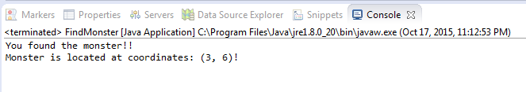

GRADING RUBRIC
Grading Criteria | 3  Exceeds  Excellent  Epic Wow | 2  Meets  Satisfactory  O.K. | 1  Partially Meets  Below Expectations  Not Yet | 0  Does Not Meet  Unacceptable  Fail
Coding | +10-Code is excellent, comments are added, and program works. | +8-Code is O.K., and program works. | +6-Code works, but still needs improvement. | 0-Unfortunately, no coding.
Output | +5-Outputs are correct, and provided additional output cases. | +3-Output meets requirement and is readable. | +1-There is output, but not readable, and/or needs improvement. | 0-Unfortunately, no output.
Testing | +5-Test cases were excellent, and provided more test cases than required. | +3-Provided valid tests, and meets minimum test case requirements. | +1-Test needs improvement, did not make sense, and did not meet minimum test case requirements. | 0-Unfortunately, no testing.
Documentation | +5-Excellent documentation. | +2-Documentation meets requirements. | +1-Documentation has misspelling, or syntax issues, or not clear, or needs improvement. | 0-Unfortunately, no documentation.
Completeness | +5-Completed all the required work and added more examples. | +2-Completed all the work required. | +1-Partially completed the work required. | 0-Unfortunately, did not complete the work required.
Content | +10-Content is excellent, and explained exhaustively each question. | +8-Content is satisfactory. | +6-Content partially meets expectation. A thorough response would have helped. | 0-Unfortunately, there is no content.
Late | Excellent, you submitted it before the deadline. | -5, for submitting after the deadline. | -10, for submitting several weeks after the deadline. | -20, unfortunately, for submitting very late.

